**GIT basic commands**

1. [**git config**](https://www.edureka.co/blog/git-commands-with-example/#git%20config) **: Usage: git config –global user.name “[name]”**

**Usage: git config –global user.email “[email address]”**

**This command sets the author name and email address respectively to be used with your commits.**

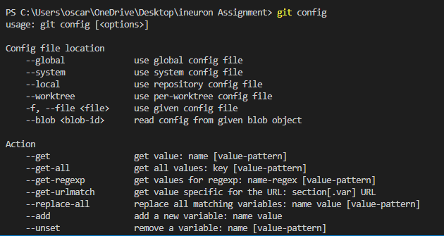

1. [**git init**](https://www.edureka.co/blog/git-commands-with-example/#git%20init)**:** **Usage: git init [repository name]**

**This command is used to start a new repository.**

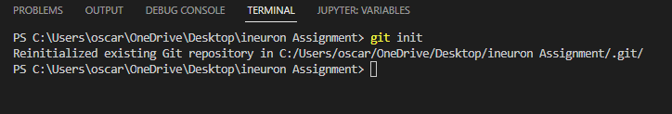

1. [**git add**](https://www.edureka.co/blog/git-commands-with-example/#git%20add) **: This command adds one or more to the staging area.**

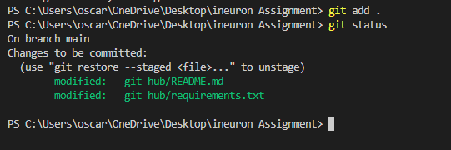

1. [**git commit**](https://www.edureka.co/blog/git-commands-with-example/#git%20commit) **: Usage: git commit -m “ Type in the commit message”**

**This command records or snapshots the file permanently in the version history.**

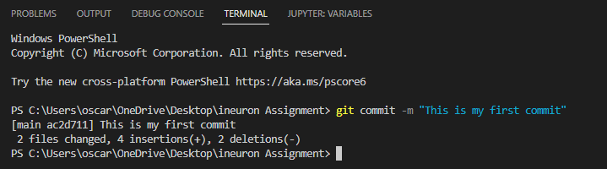

1. [**git status**](https://www.edureka.co/blog/git-commands-with-example/#git%20status) **:**Usage: git status

This command lists all the files that have to be committed.

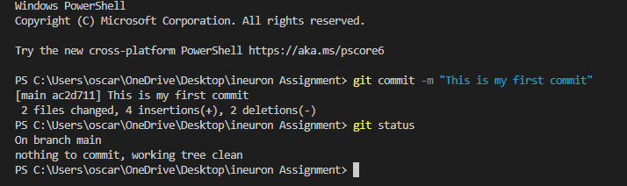

1. [**git push**](https://www.edureka.co/blog/git-commands-with-example/#git%20push) **: Usage: git push [variable name] master**

**This command sends the committed changes of master branch to your remote repository.**

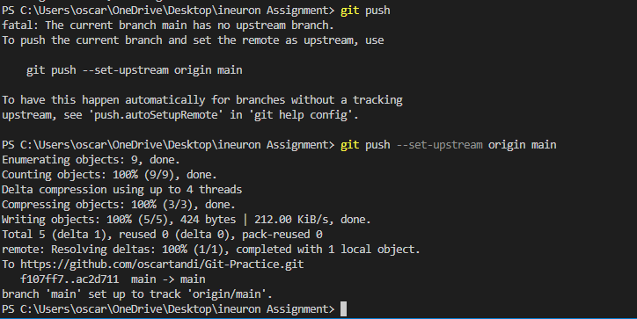**Usage: git push [variable name] [branch]**

**This command sends the branch commits to your remote repository.**

**Usage: git push –all [variable name]**

**This command pushes all branches to your remote repository.**

1. [**git pull**](https://www.edureka.co/blog/git-commands-with-example/#git%20pull) **: Usage:** git pull [Repository Link]

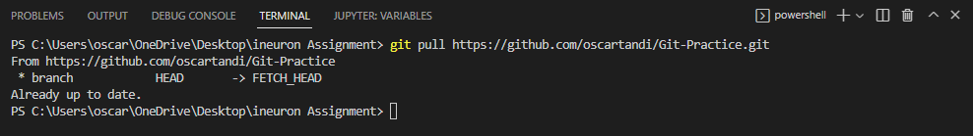 This command fetches and merges changes on the remote server to your working directory.

1. [**git clone**](https://www.edureka.co/blog/git-commands-with-example/#git%20clone) **: Usage: git clone [url]**

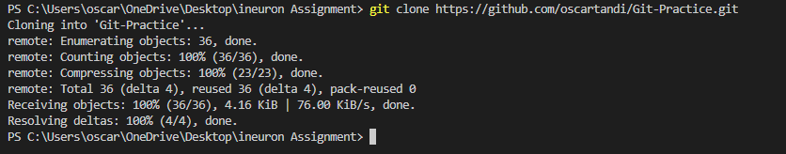**This command is used to obtain a repository from an existing URL.**

1. [**git diff**](https://www.edureka.co/blog/git-commands-with-example/#git%20diff) **:** This command shows the file differences which are not yet staged**.**



1. [**git reset**](https://www.edureka.co/blog/git-commands-with-example/#git%20reset) **:** Usage: git reset [file]

This command unstages the file, but it preserves the file contents.



1. [**git rm**](https://www.edureka.co/blog/git-commands-with-example/#git%20rm) **:** Usage: git rm [file]

This command deletes the file from your working directory and stages the deletion.

1. [**git log**](https://www.edureka.co/blog/git-commands-with-example/#git%20log) **:** Usage: git log

This command is used to list the version history for the current branch.

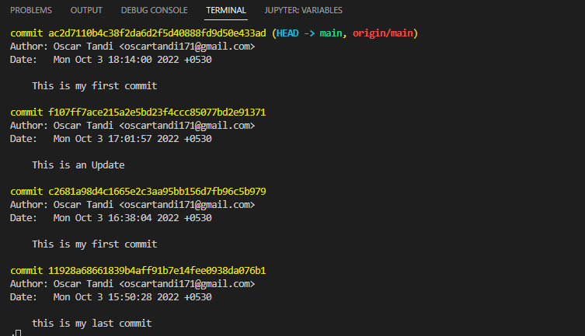

1. [**git show**](https://www.edureka.co/blog/git-commands-with-example/#git%20show) **:**

Usage: git show [commit]

This command shows the metadata and content changes of the specified commit.

1. [**git branch**](https://www.edureka.co/blog/git-commands-with-example/#git%20branch) **:** Usage: git branch

This command lists all the local branches in the current repository.

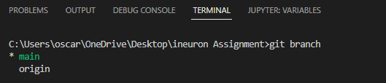

1. **git checkout**

**Usage: git checkout [branch name]**

**This command is used to switch from one branch to another.**

